# Cortex-M4 Experiments with S800 Board

## Experiment Three: UART and Interrupts

* **General Description and Goals:**

In this experiment, you should be familiar with: 1) serial communication with UART; 2) Blocking and non-blocking operations of UART; 3) interrupt-driven programming and the prioritization of interrupts.

* **Experiment Requirements:**

1. Read the example code in file exp3-1.c and understand the initialization of UART0. After the initialization, the S800 board sends a string of “HELLO, WORLD!” to the host (a PC running a serial communication software, such as ).
2. Based on the above requirement, read the so-called “UART ECHO” code in file exp3-2.c, in which the host first sends a string to the S800 and the S800 returns the received string back to the host.
3. Modify the code in Requirement 2 to use interrupts of UART0 to transmit and receive data via non-blocking operations. In addition, when the UART0 is receiving data, LED connected to PN1 will be turned on. See example code in exp3-3.c.
4. Program to implement AT comments: 1) when string “AT+CLASS” is sent from the host, the S800 returns “CLASS#####”, where ##### is your class ID; 2) when string “AT+STUDENTCODE” is send, the S800 returns “CODE******”, where ****** is your student ID.
5. Modify the above code to accept both uppercase and lowercase strings.
6. Program to implement a digital clock:

1) the clock automatically runs on every 1s after reset;

2) the host can send a “SET” command, such as “SET12:56:03” or “12-56-03” to the S800 and when received, the S800 sets its clock to this time and returns the adjusted time (in the form of “TIME12:56:03”) back to the host;

3) the host can send a “INC” command, such as “INC00:00:12” to the S800 and when received, the S800 increases its clock time by 12 seconds and returns the adjusted time back to the host;

4) the host can send “GETTIME” command to the S800 and the S800 will returns back the current clock time back to the host.

1. Interrupt priority experiment. Based on Requirement 3, change the priority level of UART0 to preempt SYSTICK. In this case, when USR_SW2 is pressed and held and the host is sending a message, the MCU will run and been stuck in the handler of UART0. If USR_SW1 is pressed, LED D2 has no response. See example code in exp3-4.c. Modify the code to make SysTick have higher priority than UART0 and check the observation when the MCU is in the handler of UART0 and USR_SW1 is pressed.

* **Related On-Board Components:**

On the LaunchPad:

|  |  |  |
| --- | --- | --- |
| Label | Connected MCU Pin | Description |
| USR_SW1 | PJ0 | User button: low effective |
| USR_SW2 | PJ1 | User button: low effective |
| D0 |  | 3.3V power indicator, green LED, high effective |
| D1 | PN1 | User green LED, high effective |
| D2 | PN0 | User green LED, high effective |
| D3 | PF4 | User green LED, high effective |
| D4 | PF0 | User green LED, high effective |

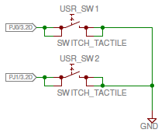

*Note that PJ0 and PJ1 connected to USR_SW1 and USR_SW2, respectively, should be programmed with weak pull-up configuration in order to get stable button status.*

On the blue board:

|  |  |  |
| --- | --- | --- |
| Label | Connected MCU Pin | Description |
| LED_M0 | PF0 | User green LED, low effective |
| LED_M1 | PF1 | User green LED, low effective |
| LED_M2 | PF2 | User green LED, low effective |
| LED_M3 | PF3 | User green LED, low effective |
| D10 |  | 3.3V power indicator, red LED, high effective |

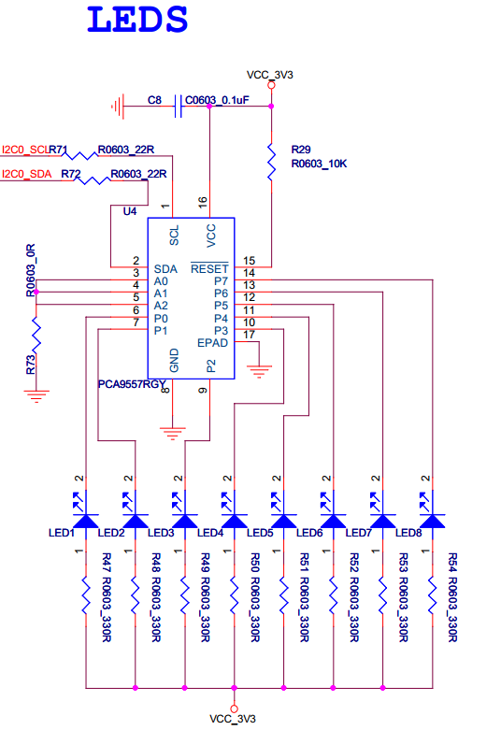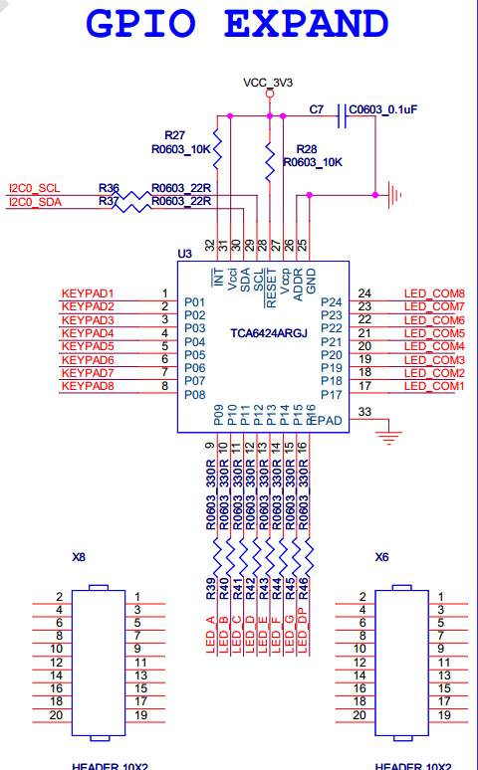

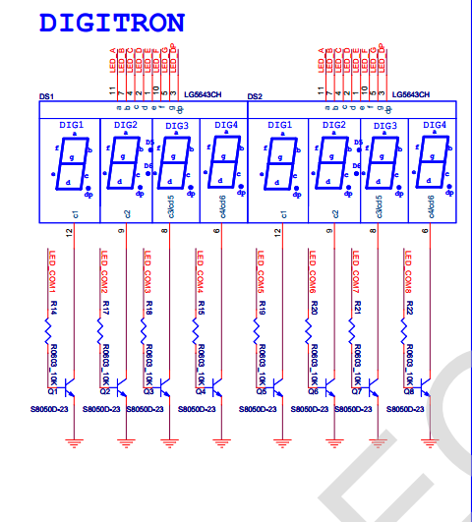

* **Related Peripheral Driver Library Functions:**

**System Clock:**

1. To configure the system clock: SysCtlClockFreqSet();
2. **For TM4C129 devices**, the return value from SysCtlClockFreqSet() indicates the system clock frequency.

**GPIO:**

1. To program on a GPIO port, first you need to supply system clock to that GPIO block using SysCtlPeripheralEnable();
2. You can check whether a peripheral is ready after clocking: SysCtlPeripheralReady();
3. To configures pin(s) for use as GPIO inputs, use GPIOPinTypeGPIOInput()and for use as GPIO outputs, use GPIOPinTypeGPIOOutput(); Sets the pad configuration for the specified pin(s), use GPIOPadConfigSet(); read a value from or write a value to the specified pin(s) use GPIOPinRead() and GPIOPinWrite(), respectively;
4. To configure the alternate function of a GPIO pin, use: GPIOPinConfigure() and to fully configure a pin, a GPIOPinType*() function should also be called.

**SysTick:**

1. To setup the initial count of SysTick: SysTickPeriodSet();
2. To enable SysTick: SysTickEnable();
3. **For software pulling**, you can read the current count of SysTick: SysTickValueGet();
4. **For interrupt-driven programming**, first you need to enable SysTick exceptions: SysTickIntEnable(); then enable the processor interrupt: IntMasterEnable(); last, implement the SysTick handler.

**I2C:**

1. To program on a I2C module, first you need to supply system clock to that I2C module using SysCtlPeripheralEnable();
2. If pins used by the I2C module is used as GPIO by default, then you need to configure these pins to the proper function;
3. Enable the I2C Master function of the I2C module using I2CMasterEnable();
4. Set the desired SCL clock speed using I2CMasterInitExpClk();
5. Specify the slave address of the master:I2CMasterSlaveAddrSet();
6. **For master writing**, place data (byte) to be transmitted in the data register: I2CMasterDataPut();start to transfer data using I2CMasterControl(); you can check whether the data transfer is completed using I2CMasterBusy();repeat this process until all data is transferred (putting an end condition when calling I2CMasterControl());
7. **For master reading**, start to receive data using I2CMasterControl(); you can check whether the data transfer is completed using I2CMasterBusBusy();get the value from the return of I2CMasterDataGet();

* **Questions:**

1. What is the purpose of line if (UARTCharsAvail(UART0_BASE)) in exp3-2.c? If it is removed from the code, what would happen?
2. Why do we need to read and clear the interrupt status in the handler of UART0 but not in the handler of the SysTick?
3. Program to send commands like “MAY+01” from the host to the S800 so that the S800 will return the result of the command back to the host. The 3-letter “MAY” represents a month in a year (JAN, FEB … DEC), “+” (or “-”) represents addition (or subtraction), and 2-letter “01” is the amount (ranging from 00 to 11) to be added to (or subtracted from) the given month. As a result, the S800 returns “JUN” back to the host after receiving “MAY+01”.
4. Program to send commands like “14:12+05:06” from the host to the S800 so that the S800 will return the result of the command back to the host. The “14:12” represents 14 minutes and 12 seconds, “+” (or “-”) represents addition (or subtraction), and “05:06” is the amount (i.e., 5 minutes and 6 seconds) to be added to (or subtracted from) the given time. As a result, the S800 returns “19:18” back to the host after receiving “14:12+05:06”.